**Thiago Gouvêa Leite**

**Brother Odom**

**WDD 230 - 2022**

# Temple Inn & Suites – Website Planning Document

## Domain Name

The domain I found available was **inntemple.com**.

You can find it and other similar domains at: [Google Domains.](https://domains.google.com/registrar/search?searchTerm=temple%20inn&hl=pt&_ga=2.65600814.1695263089.1648034562-296351394.1648034562%23)

## Site Purpose

This website’s purpose is to provide and advertise accommodations and amenities available for Temple workers, patrons and their families. It will contain specific and simple information about Temple services, reservations and its events. It will made to be a haven of comfort and accessibility.

## Target Audience

The target audience for this website is nearly everyone who has access to the internet, that lives in one of the areas that have a Temple or needs to find a closer Temple to use its services. If a person wants to know about each Temple accommodations, they are the targets for this website.

Persona 1:

Persona:

Temple Worker

**Fictional Name:**

May Parker

**Job Title:**

Retired / Housewife **Demographics:**

* 79 years old
* Married
* 4 children
* She has been a member of the Church since her childhood, serving in the Temple for almost 40 years.
* She lives far from any Temple around, the closest one is the Boston Temple.

**Goals and Tasks:**

She got a calling as a Temple worker again and is looking for nearby accommodations so as to minimize traveling time and expense.

**Environment:**

She is almost on her 80s. She doesn’t know a lot about technology, so she would appreciate to find easy resources to find accommodations to schedule her temple appointments.

**Quote:**

"The Temple is one of the most important things to me now. I wish I could make it easier to find hotel and services when I have a Temple appointment."

**Scenarios:**

* May needs to travel to fill her call as a temple worker. She doesn’t have time to search for a lot of different hotels chains.
* She decided to go to the temple late this week, but any website was showing affordable prices for the travel.
* May would love when the hotel is close to the Temple and not just in the city it is located.

**Persona 2:**

Persona:

Couple planning their wedding and sealing

**Fictional Name:**

Thomas and Martha Wayne

**Job Title:**

Business owners Demographics:

* Early twenties
* Engaged
* They need to travel a few hours to reach the Orlando Florida Temple.

Goals and Tasks:

Getting married in June. Lots of relatives & friends coming for the ceremony. Looking for affordable accommodations near the Temple.

Environment:

They usually access websites through their iPads, they always look for websites that has a good tablet accessibility. They are in a hurry to schedule everything for their wedding and sealing, as soon as possible.

**Quote:**

"We are really excited to be a family. The marriage and sealing are really important for us and our families, we know it’ll be a great step in our lives."

**Scenarios:**

* They want to find a place that offers group discounts, once not everyone that was invited would be able to pay the full amount to travel.
* Thomas has a few young age children. He wants to find a place that would have a space for them.
* Martha’s best friend is a non-member of the Church. She wants a place that would accept non-member people.

Site Map

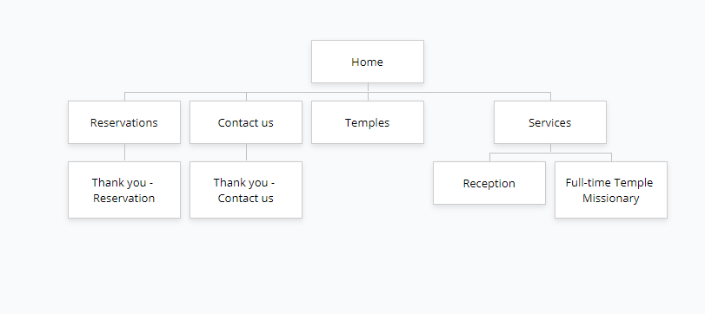

## Color Scheme

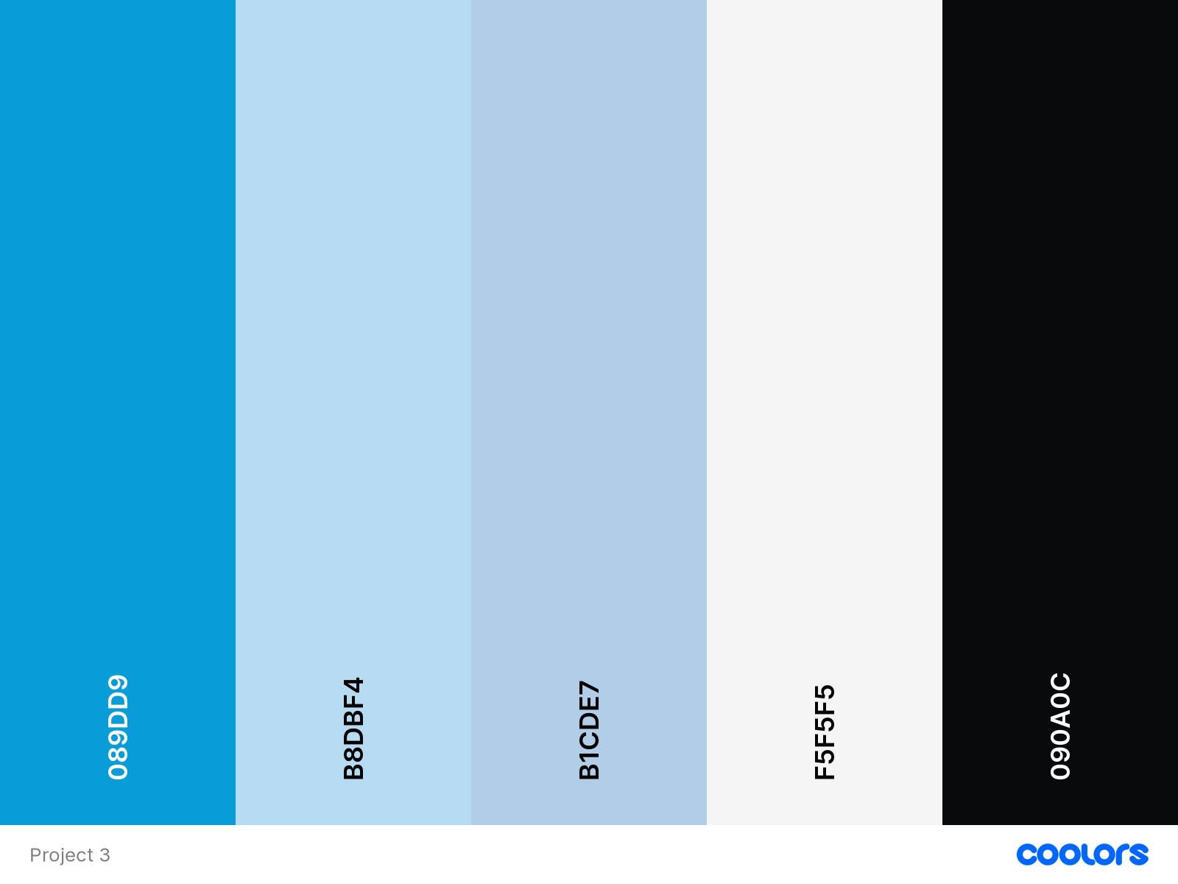

You can find this palette at [Coolors.](https://coolors.co/089dd9-b8dbf4-b1cde7-f5f5f5-090a0c) I want people to have the feeling of a safe haven when accessing this website, that’s why I chose blue tones, it has a calm feeling in it.

* **Header**: - Text Color: #089DD9, Background Color: #B8D8F4;
* **Heading 1**: - Text Color: #F5FF5F5, Background Color: #089DD9;
* **Heading 2**: - Text Color: #089DD9;
* **Heading 3**: - Text Color: #090A0C;
* **Heading 4**: - Text Color: #090A0C;
* **Nav a**: - Text Color: #F5FF5F5, Background Color: #A1C3E2;
* **Nav a.at**: - Text Color: #F5FF5F5, Background Color: #089DD9;
* **Nav a.hover**: - Text Color: #089DD9, Background Color: #F5FF5F5; • **Paragraphs**: - Text Color: #090A0C;
* **Links:** Text Color: #089DD9.

## Typograph

Site header

Font: Montserrat

Size: 6.em

#

7

FBEEB

Sample

Navigation

Font: Cormorant Garamond

Size: 1.25em

#F5FF5F5

[**S**](https://fonts.google.com/specimen/Cormorant+Garamond?preview.text=Sample&preview.text_type=custom)

[**ampl**](https://fonts.google.com/specimen/Cormorant+Garamond?preview.text=Sample&preview.text_type=custom)

[**e**](https://fonts.google.com/specimen/Cormorant+Garamond?preview.text=Sample&preview.text_type=custom)

Navigation (.at)

Font: Cormorant Garamond

Size: 1.25em

#F5FF5F5

[**Sampl**](https://fonts.google.com/specimen/Cormorant+Garamond?preview.text=Sample&preview.text_type=custom)

[**e**](https://fonts.google.com/specimen/Cormorant+Garamond?preview.text=Sample&preview.text_type=custom)

Navigation (:hover)

Font: Cormorant Garamond

Size: 1.25em

#089DD9

[**Sample**](https://fonts.google.com/specimen/Cormorant+Garamond?preview.text=Sample&preview.text_type=custom)

Footer Navigation

Font: Cormorant Garamond

Size: 1.25em

#F5FF5F5

[**Sampl**](https://fonts.google.com/specimen/Cormorant+Garamond?preview.text=Sample&preview.text_type=custom)

[**e**](https://fonts.google.com/specimen/Cormorant+Garamond?preview.text=Sample&preview.text_type=custom)

Heading 2 (h2)

Font: Montserrat

Size: 2.8em

#089DD9 Sample

Heading 3 (h3)

Font: Montserrat

Size: 1.75em

**#090A0C**

## Sample

Heading 4 (h4)

Font: Montserrat

Size: 1.25em

**#090A0C**

## Sample

Paragraph text

Font: Montserrat

Size: 1.2em

**#090A0C**

## Sample

### Wireframes

Large

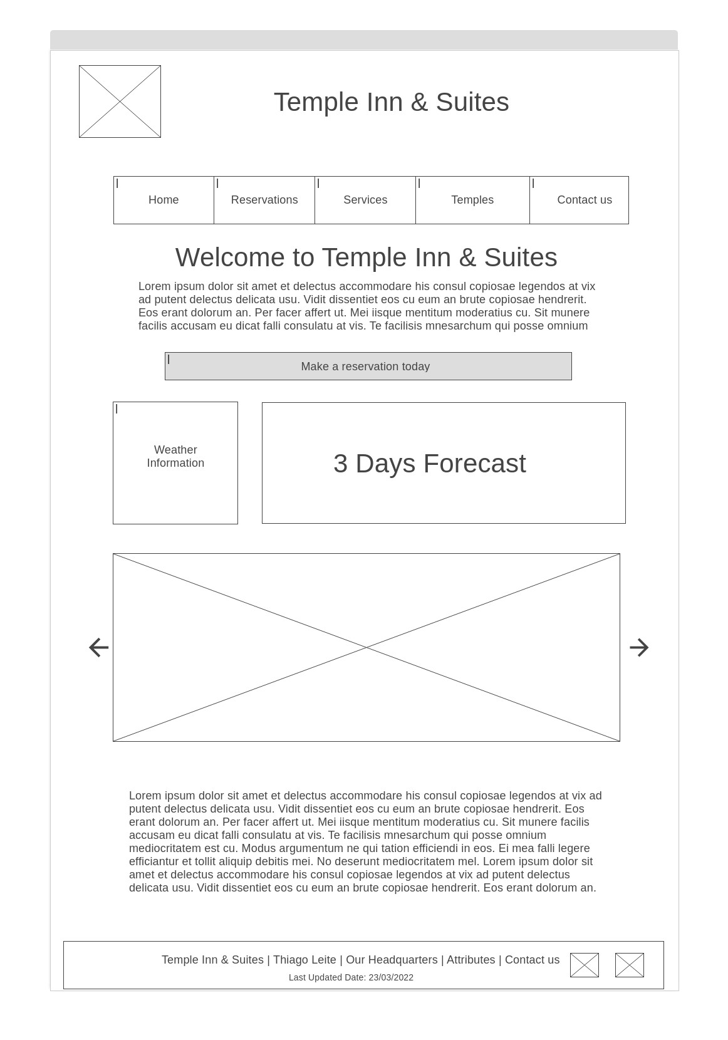

Medium

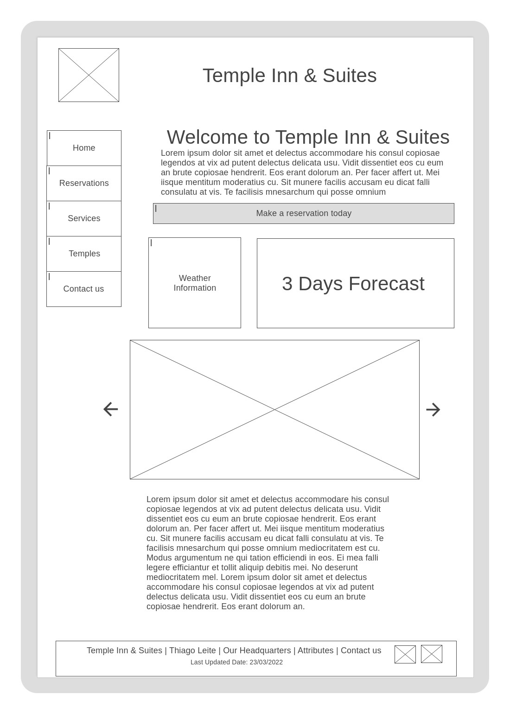

Small

